Chic Cycles

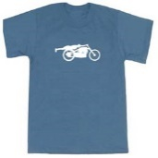
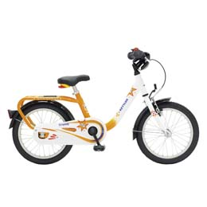
cv
cv
cv
cv
cv
cv
A bike shirt for just $19.99
A kid’s bike for only $199.99
At Chic Cycles, we are here to help you make bicycles the best part of your life. We offer bicycles, and some accessories that go with them. Look further down for some of our featured products
Home Bikes Accessories About Us Contact

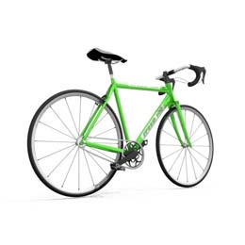

Chic Cycles

10 Speed Bike
Price: $599.99
Buy this new bike for a great price
Home Bikes Accessories About Us Contact

<- Previous Bike Next Bike ->

J. James
5 stars
I love this bike and I use it every day!
Reviews
Reviews

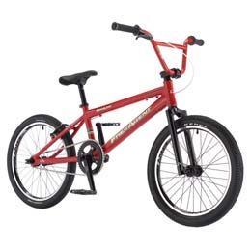

A. Allen
5 stars
This bike is good for dangerous terrains.
Reviews
Reviews
Chic Cycles

Home Bikes Accessories About Us Contact

<- Previous Bike Next Bike ->

BMX Bike
Price: $499.99
Buy this used sports bike for a discount



R. Richard
5 stars
This was my son’s first bike, and he loved it!
Reviews
Reviews
Chic Cycles

Home Bikes Accessories About Us Contact

<- Previous Bike Next Bike ->
Kid’s Bike
Price: $199.99
Buy this brand-new bike with extra safety features

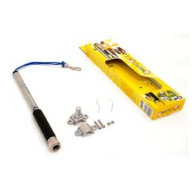

B. Brian
5 stars
I feel good knowing that my bike is safe while I work.
Reviews
Reviews
Chic Cycles

Home Bikes Accessories About Us Contact

<- Previous Accessory Next Accessory ->
Bike Lock
Price: $9.99
Buy this bike lock to keep your bike safe

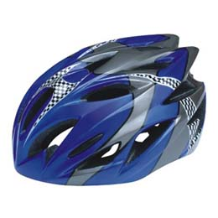
Bike Helmet
Price: $39.99
Buy this bike helmet to keep you safe

P. Patrick
5 stars
I am glad that this helmet keeps me safe while I ride my bike.
Reviews
Reviews
Chic Cycles

Home Bikes Accessories About Us Contact

<- Previous Accessory Next Accessory ->

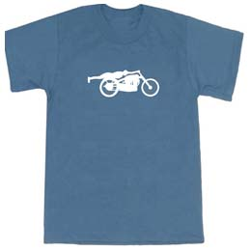

O. Oliver
5 stars
This shirt feels great and shows that I love bikes!
Reviews
Reviews
Chic Cycles

Home Bikes Accessories About Us Contact

<- Previous Accessory Next Accessory ->

Bike Shirt
Price: $19.99
Wear this shirt to show your support of bikes

